2013 Show Me Bowl Shirts For Sale

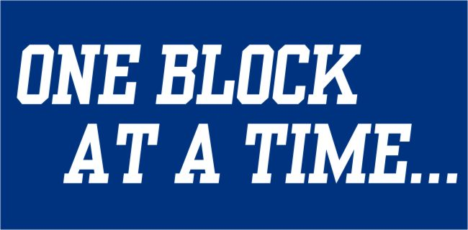

Shirts Will go on sale Wednesday November 27 at 2:30 PM
Location: Valle Fieldhouse
Cost: $12 each, only T-Shirts…no long sleeve Ts or Hoodies
Limited Quantities Available

