2016 State Championship Order Form

Shirt A (Heather Grey)
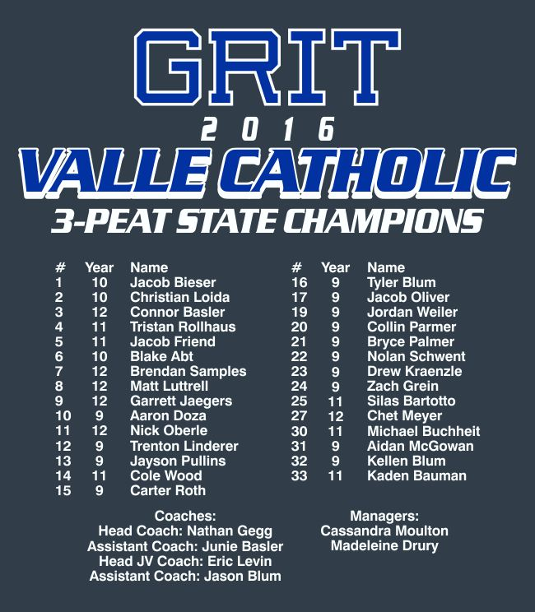
FRONT BACK

Available Products: Gildan T (YM – Adult XXXL), Adidas Performance T (No Youth Sizes)
Gildan Hood (No Youth), UA Hood (No Youth)

Shirt B (White)
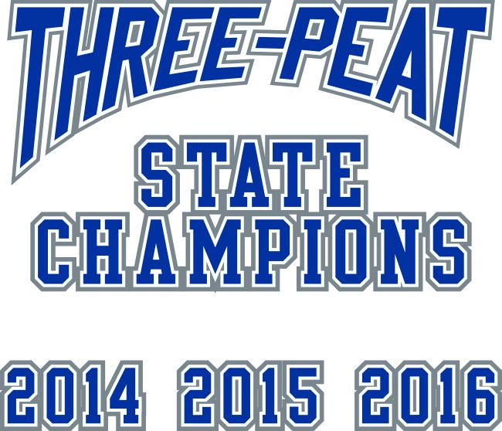
FRONT BACK

Available Products: Gildan T (YM – Adult XXXL), Adidas Performance T (No Youth Sizes),
Gildan Hood (No Youth), UA Hood (No Youth)

ORDERS: May drop off order form and money to the weight room Thursday and Friday from 7 – 8 AM or 4 – 5PM or at the high school office from 10 – 12 on Thursday and Friday.

Orders will be slightly delayed due to a couple items being out-of-stock currently. We are projected to have everything in by Friday July 8. Will update as needed.
Questions or comments: geggn@valleschools.org to arrange a dropoff or a pickup as well
Name: _________________________________________

MAKE ALL CHECKS AVAILABLE TO VALLE SCHOOLS!

Shirt Choice | Gildan Ultra T  $12 YM – XXL  $15 XXXL | Adidas Performance T  $22 AS – XXL  $24 XXXL | Gildan Hood  $25 AS - XXL  $27 XXXL | Under Armour Hood  $44 AS – XXL  $46 XXXL | Total Cost
SHIRT A (GREY)

SHIRT B (WHITE)

Total Cost of Both Shirts: $________________

